The Three Rhetorical Appeals

1. **LOGOS:** Appeal to Reason



Arguments based on logic and fact, which appeal to a reader’s sense of reason.

**Techniques**: case studies, statistics, scientific studies and data, cause-and-effect reasoning, detailed and rational explanation, hypothetical scenarios

**Using Logos:**

* Is your thesis clear?
* Have you come up with strong, relevant facts and information?
* Have you clearly explained the support and connected it to the thesis?

1. **PATHOS:** Appeal to emotion



Arguments based on language, examples and stories that stir strong emotions such as pity, anger, hope, love etc.

**Techniques:** hypothetical/imaginative stories, personal stories and examples, analogies, loaded language to engage readers’ beliefs, values, sympathies, imaginations and emotions

**Using Pathos:**

* Is your support vivid and does it clearly appeal to the reader’s emotions, values, and beliefs?
* Will your support be relatable to most or many readers?
* Be careful not to rely too much on pathos-based support, or it may come across as manipulative or unreliable.

1. **ETHOS:** Appeal based on the character/credibility of the author or someone else



Arguments that depend on the trustworthiness and reliability of the author.

**Techniques:** expert testimony**,** credentials, personal experience to suggest an expertise, reliability and formality appropriate for the topic

**Using Ethos:**

* Have you clearly highlighted your qualifications or the qualifications of one of your sources?
* Have you shown a balanced point of view and respect for different positions?
* Is the tone appropriate for the subject and audience?

____________________________________________________________________________________

**Balancing these appeals in argument**

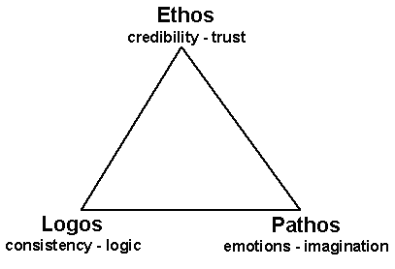

Strong arguments generally seek balance between the three appeals; however, depending on audience and purpose, different arguments may favour one appeal over the other.

* What are some benefits of favouring logos? What are some potential problems?
* What are some benefits of favouring pathos? What are some potential problems?
* What are some benefits of favouring ethos? What are some potential problems?

(With files from Indiana University University Writing Centre: <http://www.english.lsu.edu/English_UWriting/FILES/item35402.pdf>)